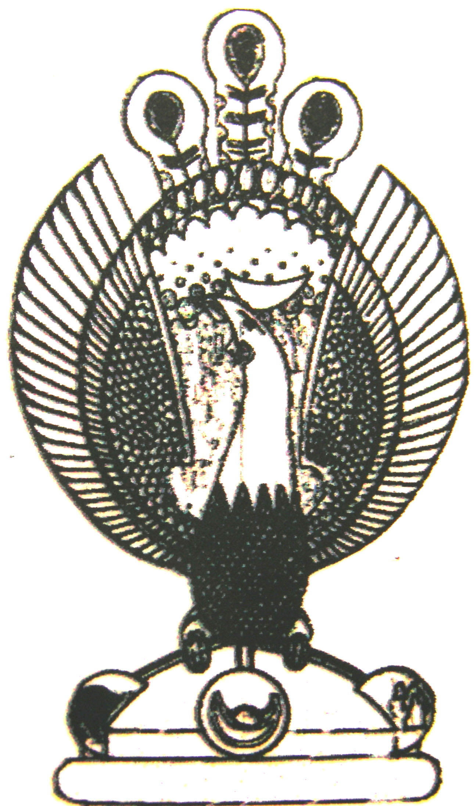

THE HERITAGE

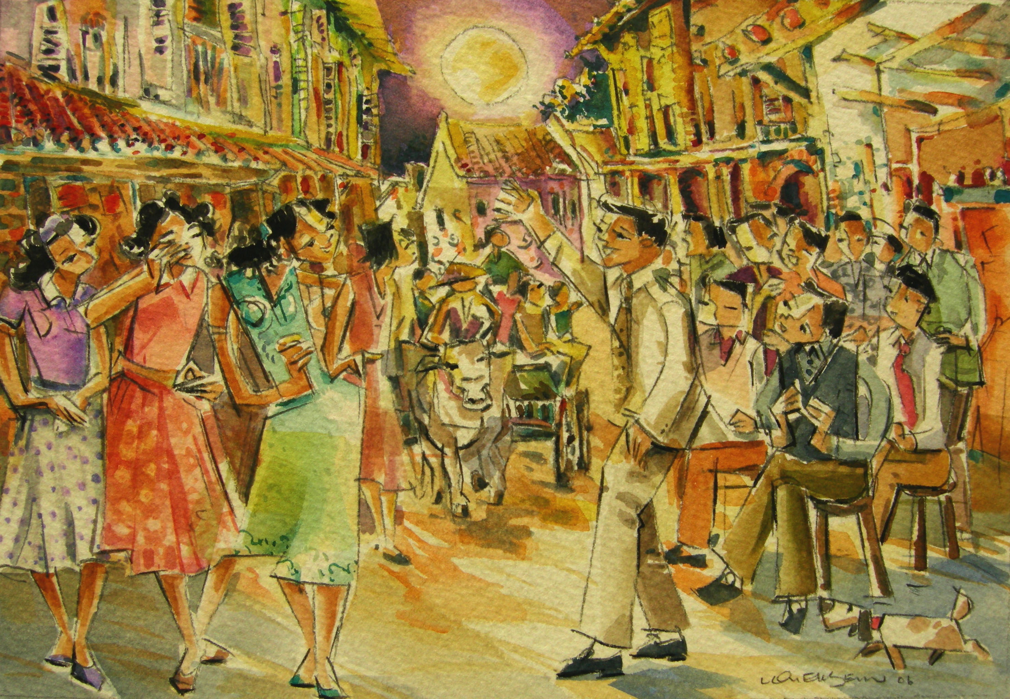
Chap Goh Meh-The outing
Chap Goh Meh. Unmarried men would sit on specially provided chairs along the road singing some verses in ‘dondang sayang’ style to capture the hearts of bypassing peranakan girls.

